Machine Learning

Python Homework

Due Date is 02-08-2020

1.Find out if the word ‘dog’ is in a string. [20 Points]

Soln:

if 'dog' in 'dog is here!': print("dog is found")

**And the output as,**

Python 3.5.6 |Anaconda, Inc.| (default, Aug 26 2018, 21:41:56)

Type "copyright", "credits" or "license" for more information.

IPython 5.8.0 -- An enhanced Interactive Python.

? -> Introduction and overview of IPython's features.

%quickref -> Quick reference.

help -> Python's own help system.

object? -> Details about 'object', use 'object??' for extra details.

PyDev console: using IPython 5.8.0

Python 3.5.6 |Anaconda, Inc.| (default, Aug 26 2018, 21:41:56)

[GCC 7.3.0] on linux

runfile('/opt/project/ifdogthere.py', wdir='/opt/project')

dog is found

2.Write a python function that accepts a string and calculate the number of upper-case letters and lower-case letters. [20 Points]

Soln:

print((lambda str: "Total upper-case letters: {} \nTotal lower-case letters: {}"\  
 .format( sum(1 for x in str if x.isupper()), sum(1 for x in str if x.islower()))) ("Help me Boy!"))

**And the output as,**

Python 3.5.6 |Anaconda, Inc.| (default, Aug 26 2018, 21:41:56)

Type "copyright", "credits" or "license" for more information.

IPython 5.8.0 -- An enhanced Interactive Python.

? -> Introduction and overview of IPython's features.

%quickref -> Quick reference.

help -> Python's own help system.

object? -> Details about 'object', use 'object??' for extra details.

PyDev console: using IPython 5.8.0

Python 3.5.6 |Anaconda, Inc.| (default, Aug 26 2018, 21:41:56)

[GCC 7.3.0] on linux

runfile('/opt/project/findTotalUpper_lowerCaseLetters.py', wdir='/opt/project')

Total lower-case letters: 7

Total upper-case letters: 2

3. Use a list comprehension to create a list of all numbers between 1 and 50 that are divisible by 3. [20 points]

Soln:

print(list(range(3, 51, 3)))

**And the output as,**

Python 3.5.6 |Anaconda, Inc.| (default, Aug 26 2018, 21:41:56)

Type "copyright", "credits" or "license" for more information.

IPython 5.8.0 -- An enhanced Interactive Python.

? -> Introduction and overview of IPython's features.

%quickref -> Quick reference.

help -> Python's own help system.

object? -> Details about 'object', use 'object??' for extra details.

PyDev console: using IPython 5.8.0

Python 3.5.6 |Anaconda, Inc.| (default, Aug 26 2018, 21:41:56)

[GCC 7.3.0] on linux

runfile('/opt/project/listof1to50DivBy3.py', wdir='/opt/project')

[3, 6, 9, 12, 15, 18, 21, 24, 27, 30, 33, 36, 39, 42, 45, 48]

4.Write a function that asks for an integer and prints the square of it. Use a while loop with a try, except, else blocks to account for incorrect outputs. [20 points]

Soln:

def squareOfIntOnly():  
 flag, p1 = True, 0  
 while flag:  
 value = input("Provide anything to square value!")  
 try:p1, flag = int(value), False  
 except:print("Provide integer only!")  
 else:print(p1*p1)  
squareOfIntOnly()

**And the output as,**

Python 3.5.6 |Anaconda, Inc.| (default, Aug 26 2018, 21:41:56)

Type "copyright", "credits" or "license" for more information.

IPython 5.8.0 -- An enhanced Interactive Python.

? -> Introduction and overview of IPython's features.

%quickref -> Quick reference.

help -> Python's own help system.

object? -> Details about 'object', use 'object??' for extra details.

PyDev console: using IPython 5.8.0

Python 3.5.6 |Anaconda, Inc.| (default, Aug 26 2018, 21:41:56)

[GCC 7.3.0] on linux

runfile('/opt/project/printSquareOfInt.py', wdir='/opt/project')

Provide anything to square value!>? as

Provide integer only!

Provide anything to square value!>? df

Provide integer only!

Provide anything to square value!>? 12

144

5.Fill in the class. Example output are given. You have to complete the coding. [20 points]

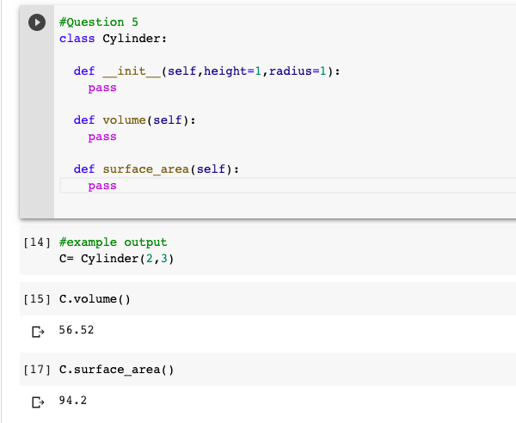

Soln:

import math  
class Cylinder:  
 height, radius = 0, 0  
 def __init__(self, height=1, radius=1):  
 (self.height, self.radius) = (height, radius)  
 def volume(self):  
 volume = math.pi * pow(self.radius, 2) * self.height  
 print(round(volume,2))  
 def surface_area(self):  
 area = 2*math.pi*self.radius*(self.radius+self.height)  
 print(round(area,2))  
C = Cylinder(2,3)  
C.volume()  
C.surface_area()

**And the output as,**

Python 3.5.6 |Anaconda, Inc.| (default, Aug 26 2018, 21:41:56)

Type "copyright", "credits" or "license" for more information.

IPython 5.8.0 -- An enhanced Interactive Python.

? -> Introduction and overview of IPython's features.

%quickref -> Quick reference.

help -> Python's own help system.

object? -> Details about 'object', use 'object??' for extra details.

PyDev console: using IPython 5.8.0

Python 3.5.6 |Anaconda, Inc.| (default, Aug 26 2018, 21:41:56)

[GCC 7.3.0] on linux

runfile('/opt/project/Assign2Q5.py', wdir='/opt/project')

56.549

94.248